Straw Towers

Subject: Architecture, Civil Engineering, Physics, Mathematics  Related Subjects: | Grade Level(s):  Length of Lesson: | Type: Inquiry / Design / Project  Keywords:

Lesson Overview
Students will design and construct a free-standing tower from straws and masking tape that will
support a textbook at least two feet above the base of the tower, with the lowest cost per inch.

Lesson Focus
What is the central question or phenomenon being investigated? What problem are they trying to solve?

Lesson Objective(s) | • Students will design and build a tower from 50 straws and 3 feet of masking tape.  • Students will construct the strongest free-standing tower to hold a textbook at least two  feet above the base of the tower with the lowest cost per inch.

Lesson Timing

5 minutes | Introduce the Lesson
30 minutes | ...

Materials | - • boxes of regular drinking straws  - • rolls of masking tape  - • measuring tape
Instructor Prep | - Step 1
Related Resources | - List related lessons/ppts etc available from USC or outside, trusted orgs

Lesson Plan

Introduction

Architects and civil engineers must design and build structures that are strong, durable, well built

and cost effective and that must meet design specifications and aesthetic standards.

Procedure
1. In groups of two, students are given 50 straws and 3 feet of masking tape.
2. Students are to construct a free-standing tower (without falling or moving towards the
floor) at least two feet above the base of the tower with the least amount of materials.
a. The height of the tower is measured from the floor or the table to the bottom of
the textbook.
b. Each straw is worth $10. Each inch of tape is worth $1.
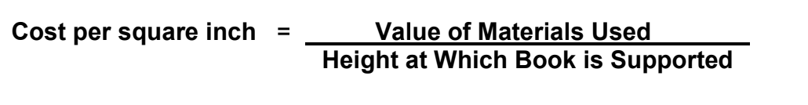
3. Students are to calculate their own cost per inch.

Wrap-up
End the lesson with some final discussions about what students designed/discovered. Connect their activity back to the focus question/problem, real world examples, and STEM careers.

Also include notes about any special cleanup considerations

Lesson Background for Teachers

Suggested Real-World STEM Connections
- List possible related Role Models in STEM (with details and links to more reading). Give suggestions for examples of scientists/engineers who are from underrepresented groups in STEM in related careers.
- List related real-world engineering problems and examples

Lesson Variations and Options
Include descriptions of alternative methods or ways to present things.

Explanation
Describe the background concepts and explanations behind the lesson. This can be more in depth than a teacher/instructor would actually share with students.

Key Concepts and Vocabulary
- Word 1: Grade Appropriate Definition
- Word 2: Grade Appropriate Definition

Safety Notes
- Safety instruction

